Becoming archaeologists and digging for artifacts.
What’s new in the new Stone Age?
Building a bronze age Hut.

STEM Essential Knowledge | Maths  - To know how to sort and count objects. (Yr1)  - To understand less than, greater than and equal to. (Yr1)  - Be able to use a place value chart for numbers up to 100 and how to count in 2s,5s and 10s. (Yr2)  - To know how to add and subtract across 10. (Yr2)  Science  - Know what materials are considered as ‘useful’ materials.  - To know and understand what absorbent objects are.  - To understand what makes a material waterproof and conduct experiments based on this.  Computing  - Know how to be safe online and understand why it is important.  - To know all about spreadsheets and how we can use them. | 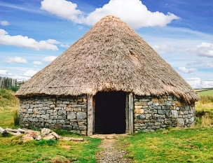  Paul Cezanne  Parakeets &  Macaws  Autumn 1      Julia Donaldson | Language and Literacy Essential Knowledge | Reading  - Predict what might happen in a story.  - To know how to answer questions about a story.  Writing  - Write a fact file all about the Bronze Age  - To know how to form letters legibly and on the line.  - Write a narrative story based on Charlie Cook’s Favourite Book by Julia Donaldson.  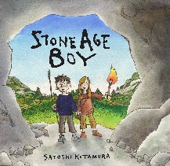  Class Text:  Stone Age Boy by Satoshi Kitamura  Charlie Cook’s Favourite Bok by Julia Donaldson
Humanities Essential Knowledge | History  - To know all about the Bronze Age.  - To understand the different roles and responsibilities in the Bronze Age.  - To be able to build a Bronze Age Roundhouse.  R.E.  - To know what makes a leader and some examples of leaders such as Moses and St Peter.  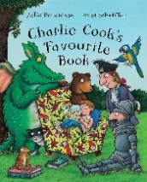  - To know what the word inspiration means and give examples of someone who is inspirational.  Significant Individual  - Julia Donaldson |  | Arts Essential Knowledge | Music  - To know what a melody is and use a percussion instrument in rhythm.  - Practice songs for the Harvest Festival.  Art  - To know who Andy Goldsworthy is and key themes of his art.  - Create natural compositions  - To know what a wax resit and create their own. | Wellbeing/RSE/ Forest School | PHSE  - To know that classroom rules keep everyone safe.  - To know that people have different ways of expressing their feelings.  PE  - Know how to dance with a partner and create different formations.  - To be able to catch and bounce a ball.  - Understand how to pass and receive a ball.

