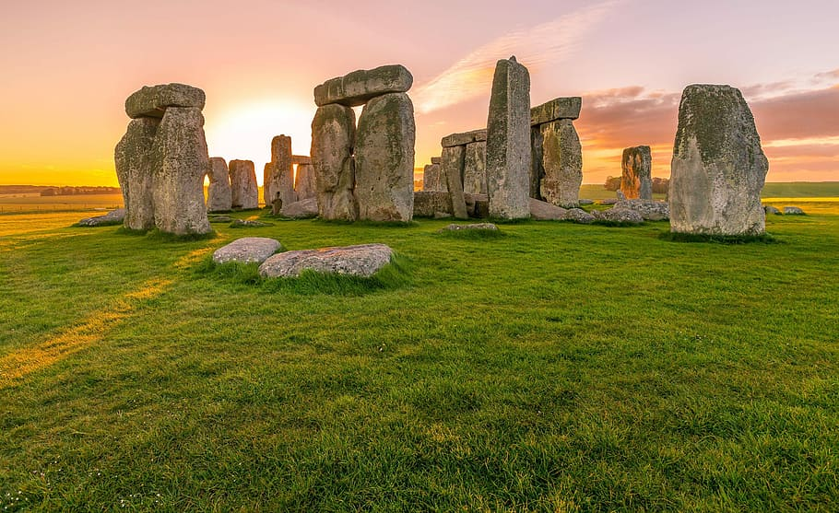
//
5. Can you write a story just like Charlie Cook has been reading?
Is there…. A pirate?
Maybe some…. Animals?
Or even…. A Dragon?

3. Can you practice forming your letters beautifully on a line ready for our first published piece of writing?
letter-formation.pdf

6. Our significant Individual this term is Julia Donaldson.
Can you find and read a book that is written by Julia Donaldson?
Once you have read it come and tell us what your favourite part was!

4. In science we are looking at useful materials.
Can you find and test some materials at home to see whether they are waterproof or not?
Write down or take a picture of the materials that your test!

Every week you will get a new sound to learn. Can you write these words in a special sentence?

Remember to keep reading a little bit every night!
1. Can you practice writing your numbers to 10, 20, 30, 40, 50 or even 100?
I wonder who can write the most…
2. We are looking at the Bronze Age this term. Could you create a Bronze Age Hut Picture?
You could use; Paint, play dough, colouring pencils, natural resources (twigs, leaves).

When you have finished a project, please bring in a picture of your outcome or writing you have completed to school to show us.
We LOVE to see all of your amazing learning!

What’s new in the new Stone Age?
Home Learning Menu
Autumn 1

