Is it our responsibility to look after the rainforest?
‘Magical’ Tunnel into Forest School
Non-Chronological report.
DT Bird House

STEM Essential Knowledge | Maths  - To know multiplication and division of 2s, 5s and 10s. (Yr1)  - To recognise half and a quarter of an object with fractions. (Yr1)  - To recognise a third and understand fractions. (Yr2)  - To know hours, quarter of hour and minutes. (Yr2)  Science  - Know different parts of a plant and how they support the plant to grow.  - To know how to set up a simple practical enquiry to classify, compare, pattern-seek and observe changes over time.  Computing  - Know how to use coding to create a fairytale story and make the characters move.  - To know how to create pictures using codes. | 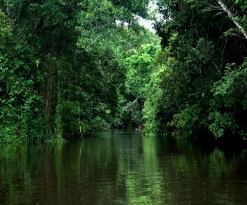  Paul Cezanne  Parakeets &  Macaws  Summer 1  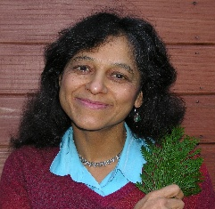    Nalini Nadkarni | Language and Literacy Essential Knowledge | Reading  - Predict what might happen in a story.  - To know how to answer questions about a story.  Writing  - To know how to form letters legibly and on the line.  - Write a narrative story based on The Tunnel by Anthony Browne.  - To know how to write a non-chronological report about the Amazon Rainforest.  Class Text:  The Tunnel by Anthony Browne.
Humanities Essential Knowledge | Geography  - To know and name six or more trees and animals in the British woodland and Amazon Rainforest.  - To know symbols for forestry on OS maps and colours on vegetation belt maps.  - To know and use the term deforestation.  R.E.  - To know how to give an example of how I feel to belong.  - Know that Jesus was baptised and why it was significant.  - To know the parts of a church that are used during a Christening.  Significant Individual  - Nalini Nadkarni  - A forest ecologist who studied the rainforest canopies. |  | Arts Essential Knowledge | Music  - To know how to identify different qualities of sounds.  - To be able to create their own rainforest soundscape.  DT  - To know what materials are strong.  - To know how a wide base helps structures.  - To create a birdhouse using recyclable materials. | Wellbeing/RSE/ Forest School | PHSE  - To know what food we need to be healthy.  - To recognise the importance of hygiene.  - To know that a new skill requires practice and feedback.  PE  - Know different speeds of running.  - To know different jumping patters.  - To be able to throw and aim at a target.

