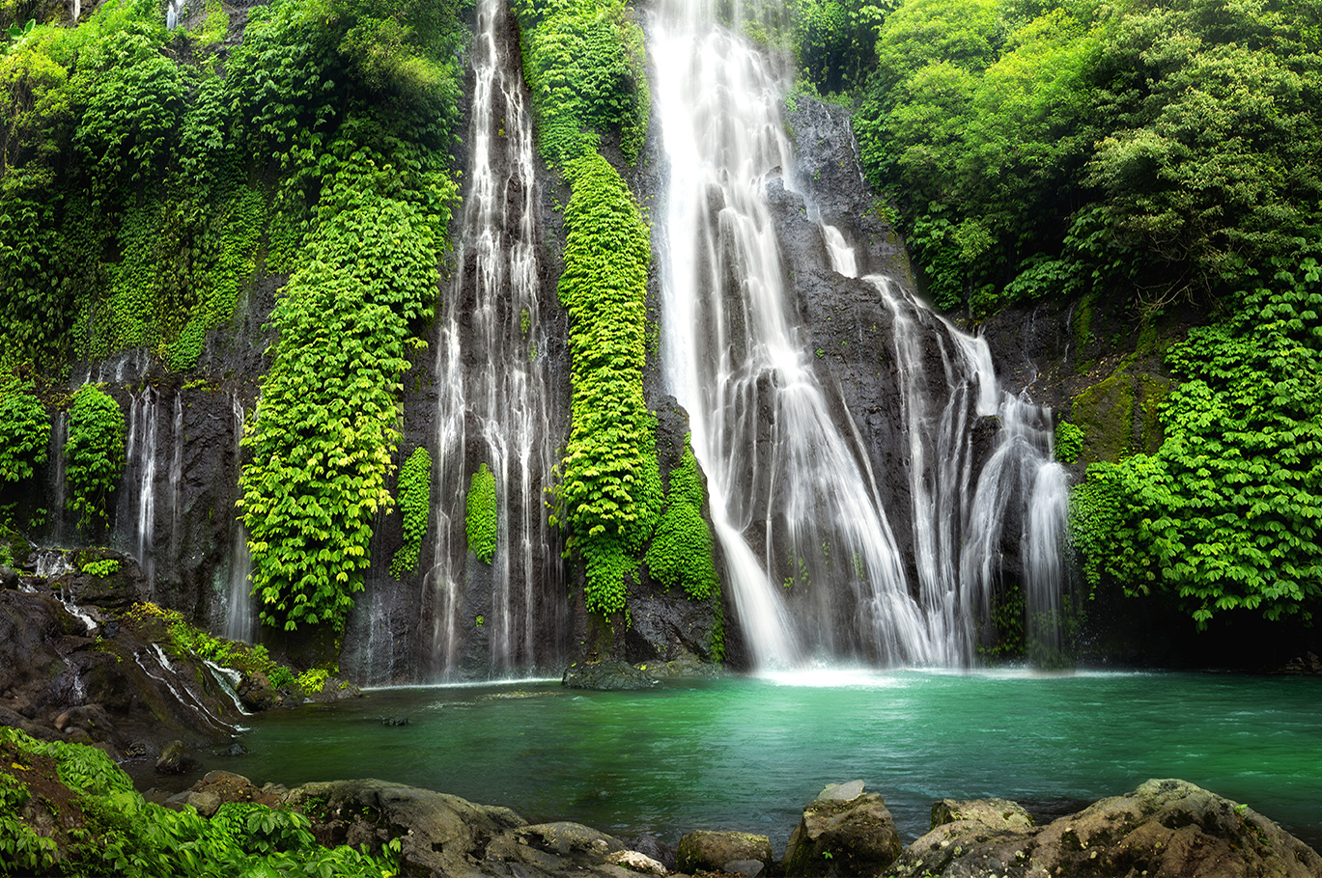
5. Can you write me a short story about going through a magical tunnel into a far away land?
Try and think of a different idea to your English learning e.g.
Candy land, under sea castle, space, pirate island, dinosaurs, sky kingdom.

3. Can you practice forming your letters beautifully on the line?
Remember, not too big and not too small.
letter-formation.pdf

6. Our significant Individual this term is Nalini Nadkarni.
Can you find out some information about her and create a fact file?
Where is she from? What did she do?
4. Can you find a book written by our author of the month Jill Murphy?
Have a read with your grown up and tell me what your favourite part was!

Every week you will get a new sound and spellings to learn. Can you write these words in a special sentence?

Remember to keep reading a little bit every night!
1. Can you practice your 2’s, 5’s and 10 times tables?
Have a go on hit the button and see how many you can get right in a minute!

2. We are looking at the Amazon Rainforest. Could you create a picture of it?
You could use; Paint, play dough, colouring pencils, natural resources (twigs, leaves).

When you have finished a project, please bring in a picture of your outcome or writing you have completed to school to show us.
We LOVE to see all of your amazing learning!

Is it our responsibility to look after the rainforest?
Home Learning Menu
Summer 1

