How do we know about the Great Fire of London?
Pudding Lane Fire
Becoming an architect.

STEM Essential Knowledge | Maths  - To know place value within 100. (Yr1)  - To know days, months and time. (Yr1)  - To know, draw and interpret pictograms. (Yr2)  - To know how to describe movements and turns. (Yr2)  Science  - Know some familiar examples of pushes and pulls.  - To know effects of applying greater or less force on an object.  - To know how to draw conclusion by interpreting data with support to generate simple comparative statements based on their evidence.  Computing  - Know how to use coding to create a fairytale story and make the characters move.  - To know how to create pictures using codes. | 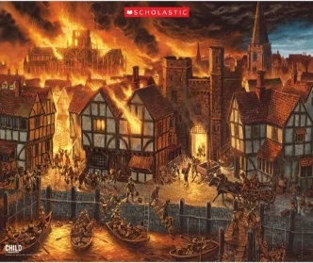  Paul Cezanne  Parakeets &  Macaws  Summer 2  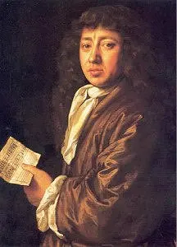    Samuel Pepys | Language and Literacy Essential Knowledge | Reading  - Predict what might happen in a story.  - To know how to answer questions about a story.  Writing  - To know how to form letters legibly and on the line.  - Write a narrative story based on The Princes and the pea by….  - To know how to write a diary entry based on the story Toby and the Great Fire of London by….  Class Text:  The princes and the pea by Peter Bently  Toby and the Great Fire of London by Margaret Nash and Jane Cope
Humanities Essential Knowledge | History  - To know some key years, including the Great Fire of London.  - To know one or more reasons why an event happened in the past.  - To know about the life of a famous Briton.  R.E.  - To know the story of David vs Goliath.  - Know about the story of Noah’s Ark and its significance.  - To know the 10 commandments from the Torah and how it guides Jews on how to live.  Significant Individual  - Samuel Pepys  - English writer who kept a diary based on the Great Fire of London. |  | Arts Essential Knowledge | Music  - To know how to identify different qualities of sounds.  - To know how to learn a song in a different language.  Art  - To know what an architect is.  - To know how to use drawing to record ideas and experiences in a sketchbook.  - To create a masterpiece outcome in the style of Hundertwasser. | Wellbeing/RSE/ Forest School | PHSE  - To understand that my body gets energy from food, water and air.  - To explain the difference between teasing and bullying.  - To identify parts of the body that are private.  PE  - Know how to balance a ball on a racket.  - To know how to play tennis with a partner.  - To be able to play a game of cricket.

