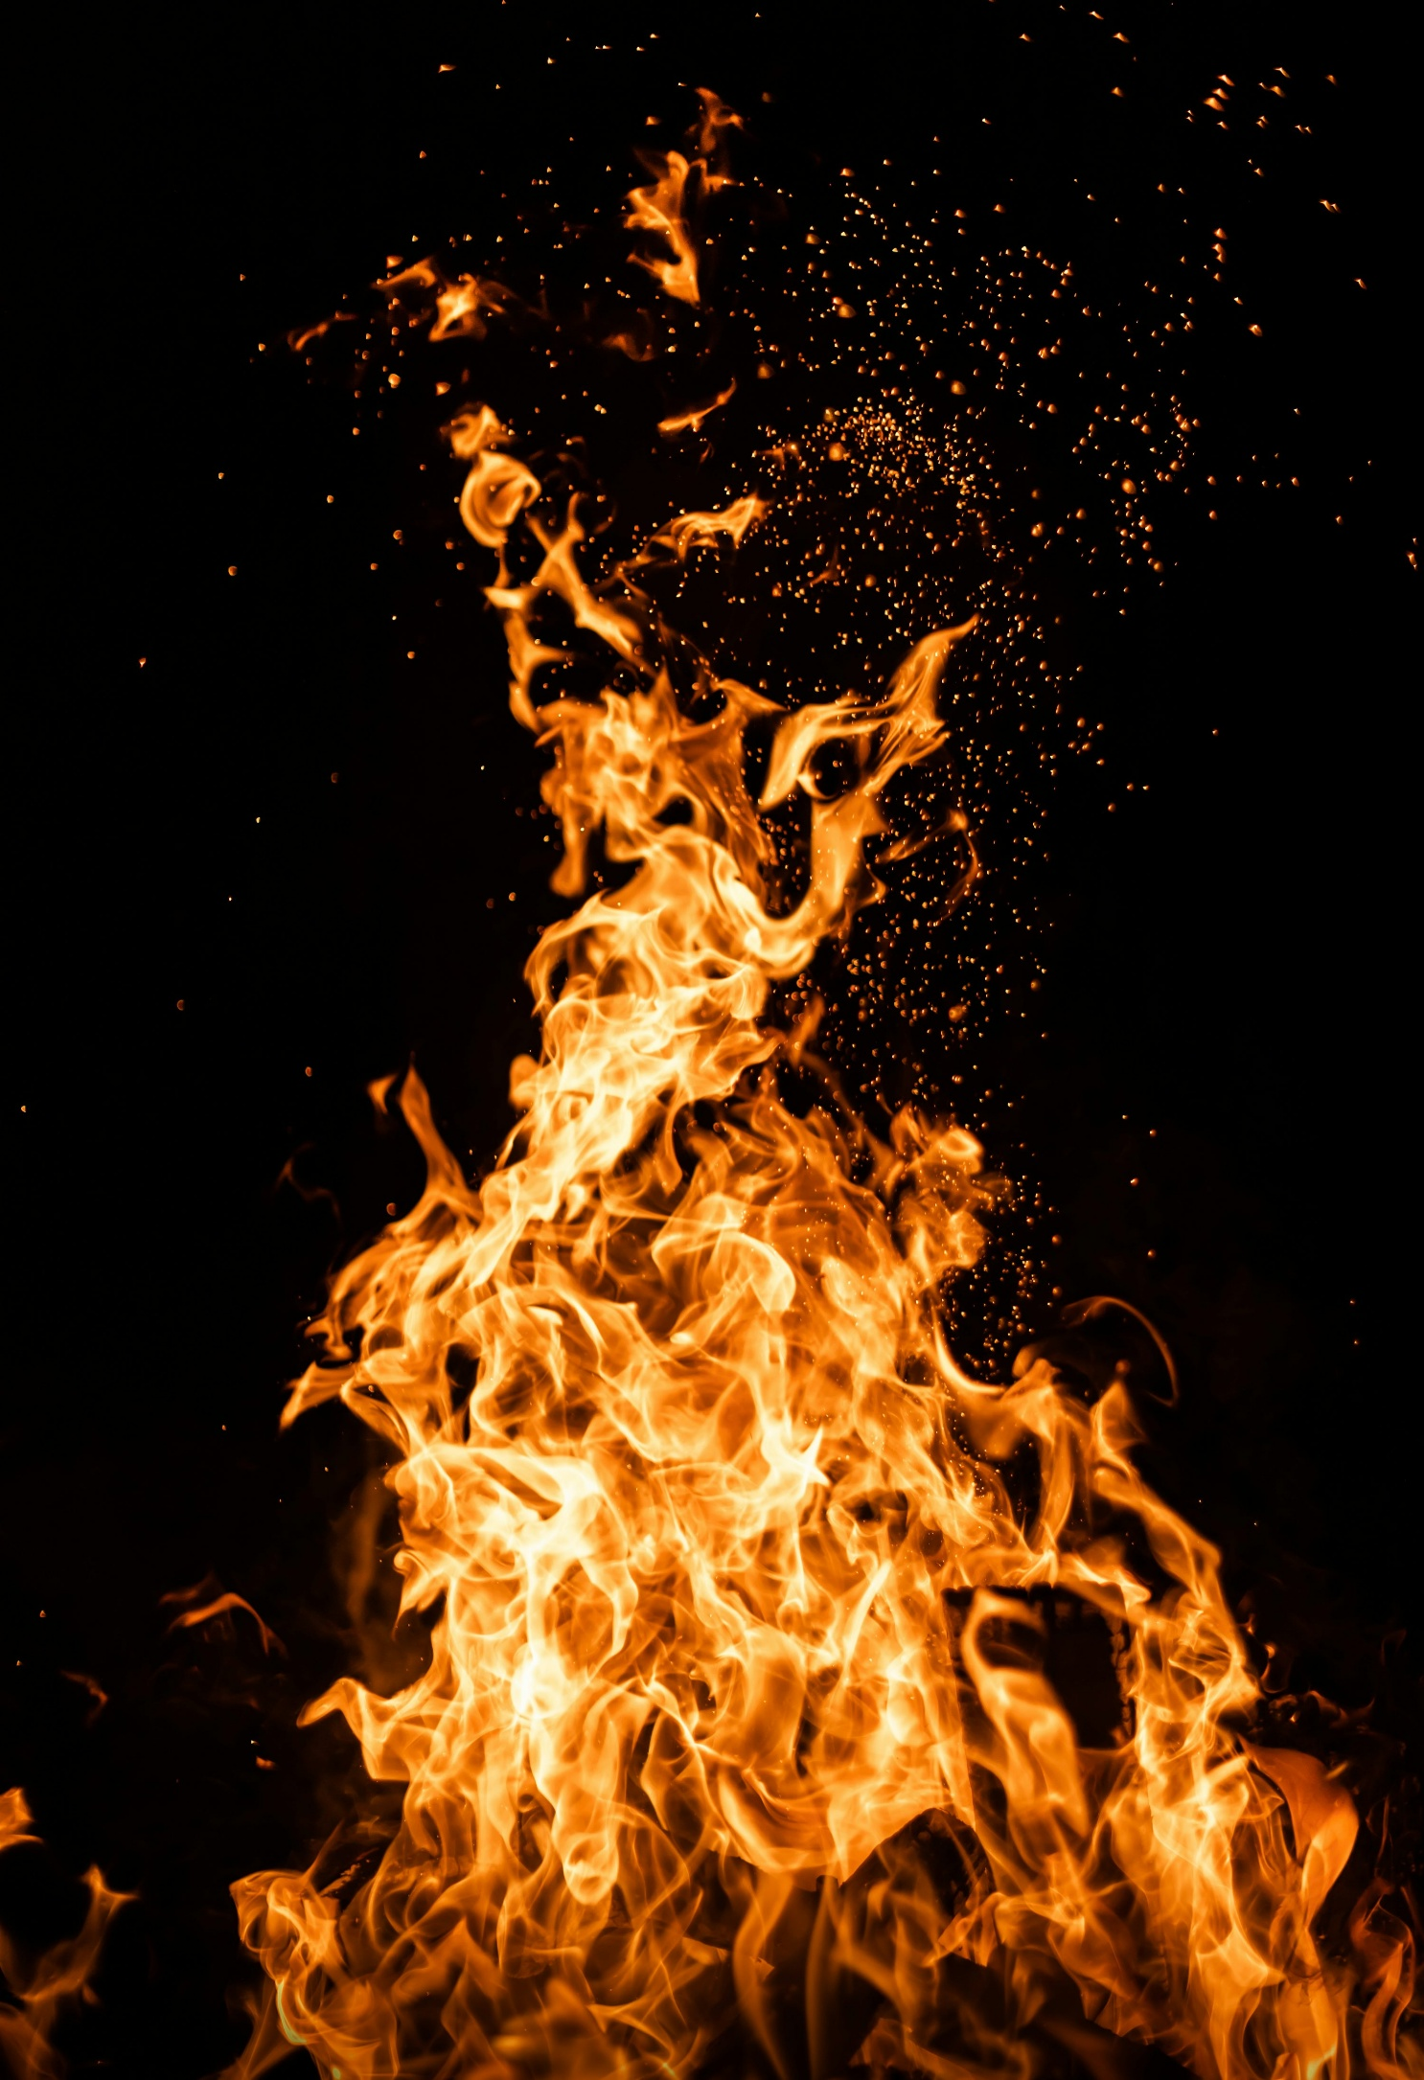
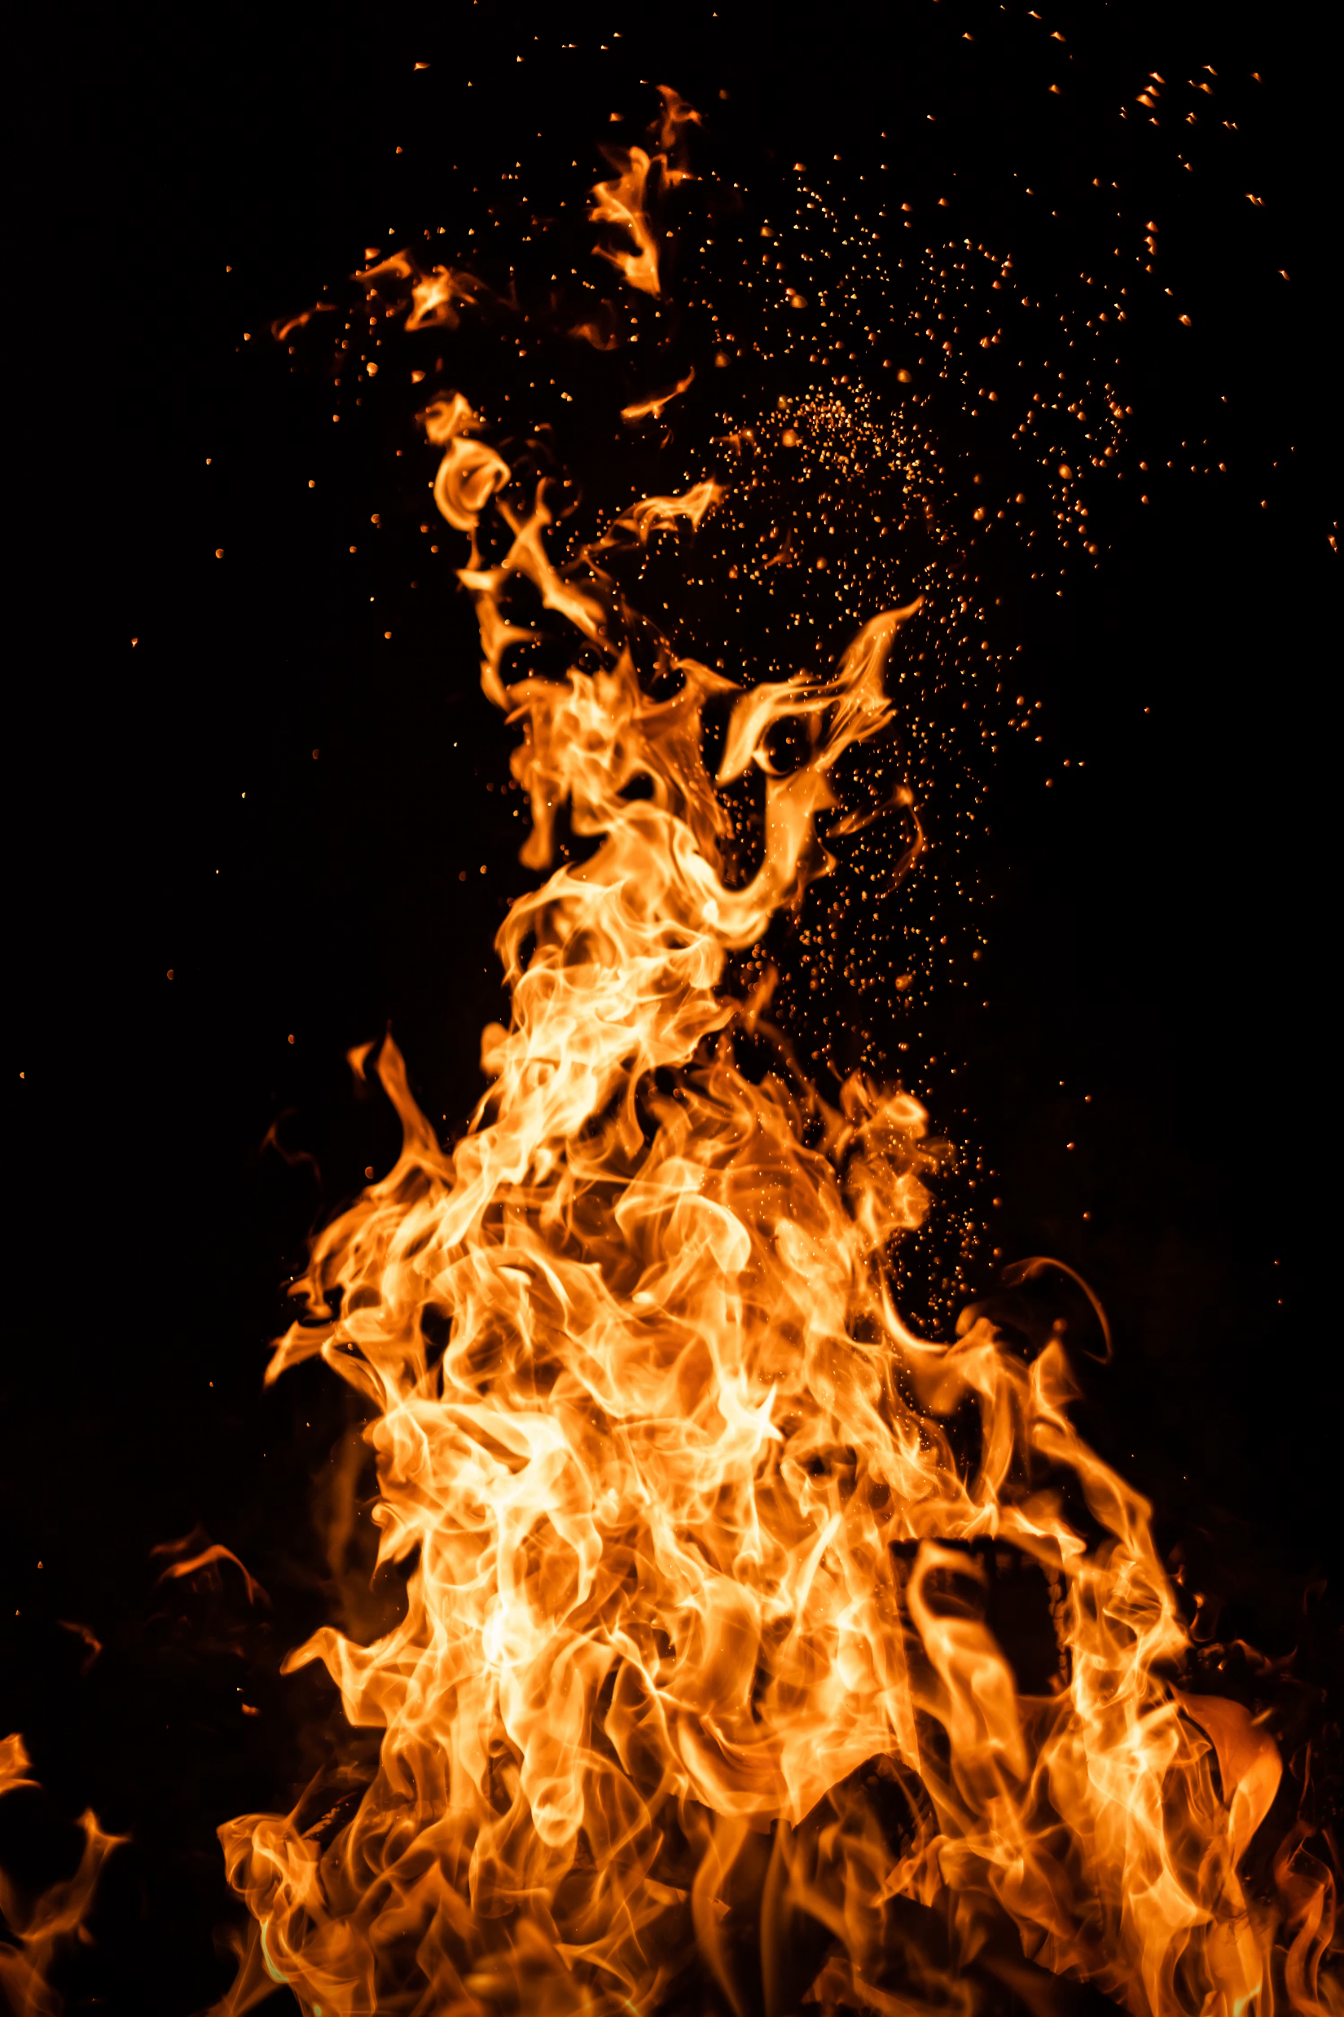
5. Can you write me a diary about your favourite part of year 1?
It could be your favourite piece of learning, your favourite activity or a trip that we went on!

3. Can you practice forming your letters beautifully on the line?
Remember, not too big and not too small.
letter-formation.pdf

6. Our significant Individual this term is Samuel Pepys.
Can you find out some information about him and create a fact file?
Where is he from? What did he do?
4. In art this half term we are going to become architects and look at different designs of Hundertwasser.
Using recyclable materials can you have a go at building your own building in the style of Hundertwasser?

Every week you will get a new sound and spellings to learn. Can you write these words in a special sentence?

Remember to keep reading a little bit every night!
1. Can you practice your addition and subtraction on hit the button?
Have a go and see how many you can get right in a minute!

https://www.topmarks.co.uk/maths-games/hit-the-button

2. We are looking at the Great Fire of London. Could you create a picture of it?
You could use; Paint, play dough, colouring pencils, natural resources (twigs, leaves).

When you have finished a project, please bring in a picture of your outcome or writing you have completed to school to show us.
We LOVE to see all of your amazing learning!

How do we know about the Great Fire of London?
Home Learning Menu
Summer 2

