What clues did the Stone Age people leave behind?
Stone Age Foragers and Makers
Create a Stone Age sculpture

STEM Essential Knowledge | Maths  - To know how to sort and count objects. (Yr1)  - To understand less than, greater than and equal to. (Yr1)  - Be able to use a place value chart for numbers up to 100 and how to count in 2s,5s and 10s. (Yr2)  - To know how to add and subtract across 10. (Yr2)  Science  - Know what materials are considered as ‘useful’ materials.  - To know and understand what absorbent objects are.  - To understand what makes a material waterproof and conduct experiments based on this.  Computing  - Know how to be safe online and understand why it is important.  - To know how to programme a simple robot. | 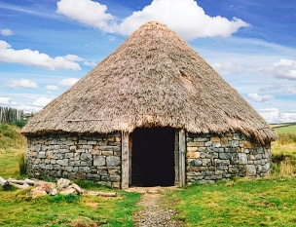  Paul Cezanne  Parakeets &  Toucan  Autumn 1  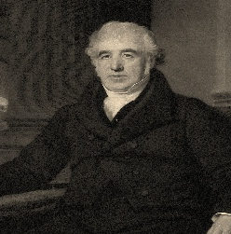    Charles Macintosh | Language and Literacy Essential Knowledge | Reading  - Predict what might happen in a story.  - To know how to answer questions about a story.  Writing  - To know how to write short captions/sentences.  - To know how to form letters legibly and on the line.  - Write and create an interactive museum display.  Class Text:  The Three Little Pigs  Teacher written fact file on the Stone Age  Harvest Festival poem
Humanities Essential Knowledge | History  - To know all about the Stone Age.  - To understand why people used to create cave paintings and what they meant.  - To be able to discuss and talk about Stone Henge.  R.E.  - To know that everyone is unique and special.  - To understand why caring for the earth and animals matter.  Significant Individual  - Charles Macintosh  - Invented the raincoat. (Science link) |  | Arts Essential Knowledge | Music  - To know about active listening with movement, beat, echo singing and pitch.  - Practice songs for the Harvest Festival.  Art  - To know that 3d dimension art is known as a sculpture.  - Create a sculpture based on the Stone Age.  - To know we can generate ideas through careful exploration. | Wellbeing/RSE/ Forest School | PHSE  - To know that classroom rules keep everyone safe.  - To know that people have different ways of expressing their feelings.  PE  - Know how to dance with a partner and create different formations.  - To learn different types of jumping and rolling.  - To be able to create a performance.

