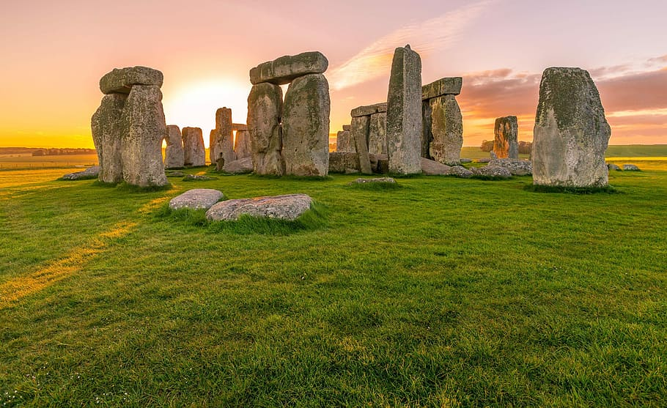
//
5. Can you turn a box (tissue, shoe, cereal) into a Stone Age cave?
You could use; Paint, play dough, colouring pencils, natural resources (twigs, leaves).

3. Can you draw a family portrait and label it?
Can you write why everyone is unique and special?
(RE Link)

6. Our significant Individual this term is Charles Macintosh.
He invented the raincoat!
Can you find out some information about him for our science learning?
4. In science we are looking at useful materials.
Can you find and test some materials at home to see whether they are waterproof or not?
Write down or take a picture of the materials that your test!

Every week you will get a new spellings to learn ready for you quizzes on Friday! Practice, practice, practice!!

Remember to keep reading a little bit every night!
1. Can you practice writing your numbers to 10, 20, 30, 40, 50 or even 100?
I wonder who can write the most…
Don’t forget to make sure your numbers are formed correctly!
2. We are looking at the Stone Age this term. Could you create a Stone Age Picture?
It could be; tools, jewellery, houses, stone henge, woolly mammoth

When you have finished a project, please bring in a picture of your outcome or writing you have completed to school to show us.
We LOVE to see all of your amazing learning!

What clues did the Stone Age people leave behind?
Home Learning Menu
Autumn 1

