How Roman was Roman Britain?
Wow Launch
Trip to Lincoln Castle
Roman Crests
Masterpiece Outcome
Roman Mosaic Piece

STEM Essential Knowledge | Maths  - Place value – the children will progress with their understanding of number values to 1000 (Y3) and 10,000 (Y4), being able to correctly order, compare, estimate and partition with these numbers.  - Addition and subtraction – the children will continue to develop their mental arithmetic and written methods, including column method with exchanging.  Science  - Light comes from a light source.  - Light sources can be natural or artificial.  - Transparency is a measure of how much light passes through a material (transparent, translucent, opaque)  Computing  - Networks – knowing that this is two or more devices connected. Children will be identifying key parts of the school network.  - Databases – children will be using comparison cards and databases, exploring the concepts or sorting and filtering by learning about records, fields and data. | 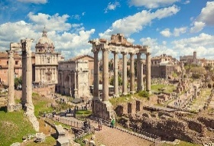  Larks and Puffins Y3/4  Autumn Term 1  Significant Individual  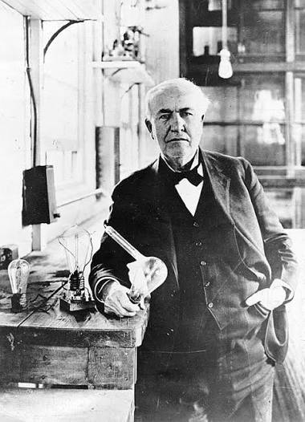  Thomas Edison | Language and Literacy Essential Knowledge | Reading  - Year 3 and 4 will explore the texts of ‘Romans on the Rampage’ – Jeremy Strong, ‘Escape from Pompeii’ – Christina Ballit and ‘Meet the Ancient Romans’ – James Davies. As we start our year we will develop our fluency and stamina with reading, focusing on word level vocabulary techniques and literal retrieval.  Writing  - Children will write a short story with tension and suspense capturing readers imagination based on the book ‘Escape from Pompeii’.  - Children will write a discussion addressing, ‘Were Roman towns better places to live than towns today?’  French  - Children will work on ‘This is me’, forming phrases to introduce themselves and have a short conversation about how each other is feeling.
Humanities Essential Knowledge | History  - The Romans lived over 2,000 years ago. They built a huge empire that spread across Europe, parts of Africa, and the Middle East. Romans came to Britain in AD 43.  - Romans built roads, towns, baths, and forts.  - Roman soldiers were called legionaries.  - Hadrian's Wall was built in AD 122 to help protect Roman Britain.  - The Romans left Britain in AD 410.  R.E.  - What difference does it make to be a Christian?  - How do Christian people’s beliefs about God, Jesus, the world and others have impact on their lives?  - Pupils will explore Christian beliefs about creation, God, community and commitment to God and humanity. They will also explore values, including love, generosity, patience, faithfulness and self-control which are part of all faiths. |  | Arts Essential Knowledge | Music  - I’ve been to Harlem - A traditional pentatonic song about travelling around the world, full of creative possibilities. We will invent cup rhythm games, explore pentatonic melodies from around the world, sing as a round, and compose ostinato accompaniments.  Art  - Mosaics – we know that people and settlements in the past used existing materials to make art.  - The class will learn about mosaic pattern and how the Romans used mosaic patterns to make tiles, a technique that is still used today. | Wellbeing/ RSE/ PE | PHSE  - Describe how our minds and bodies, physical factors and how a person feels can affect emotions, actions and decisions.  - PE  - Hockey, we will continue to build on attack and defence skills, applying this to small games.

