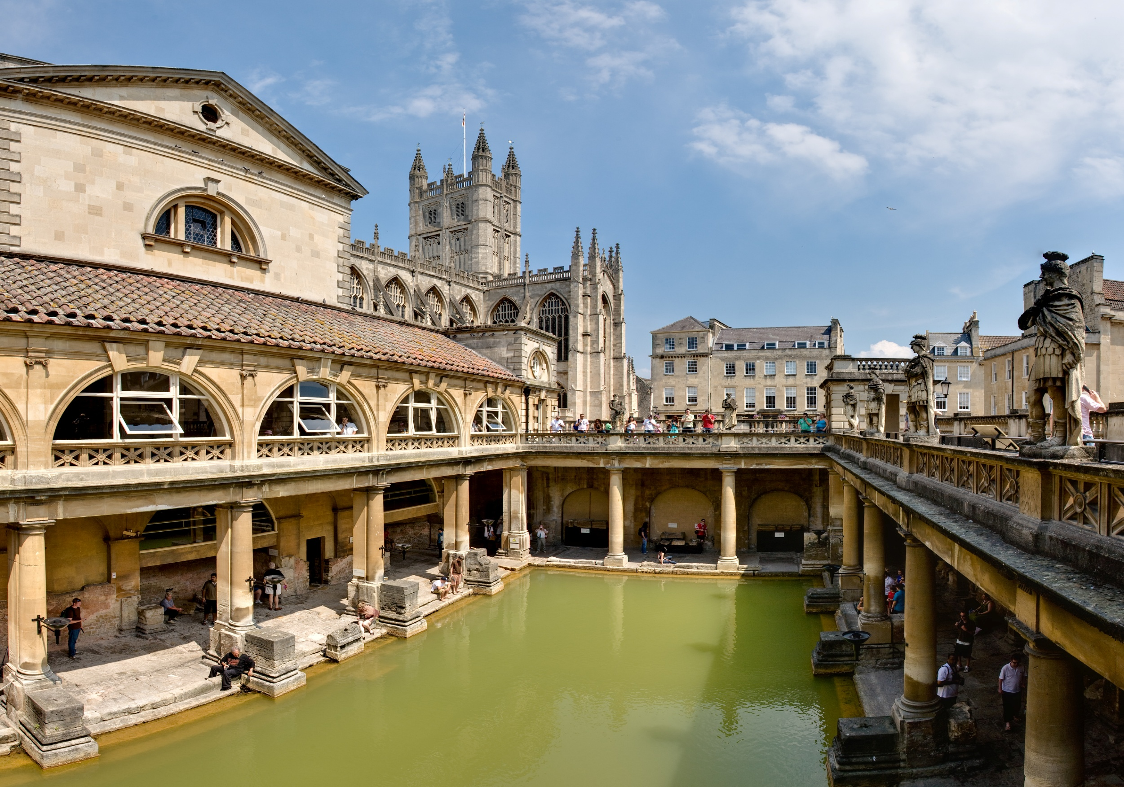
Maths:
Practise your multiplication facts.
Year 3 – 2’s, 5’s, 10’s and 3’s
Year 4 – 3’s, 4’s, 8’s and 6’s
Enjoy TT rockstars!
History:
Could you make a larger Roman shield using cardboard and foil and any other recycling pieces?
Could you make a Roman villa with your recycling materials?
Or could you make a head wreath with leaves like senior Romans would have worn?
Significant Individual:
We will be finding out about Thomas Edison, linked to our science learning about ‘Light’. What can you find out about him? Are there any other significant people linked to Romans or science and light?
English writing:
Take time to practise your beautiful joined writing.
Please share with us any amazing stories or writing that you do!
Science:
Can you investigate light and shadows with a torch? What happens when you are at different distances and angles with the torch?
Spelling Practise:
Keep an eye on reading records for your weekly spelling lists. Spend a few minutes each day familiarising yourself with your spelling rules and sounds.
Aim for a great score each week!

Reading for Pleasure:
We all reading book on the go at the moment. Enjoy time reading to yourself and to others. If you really enjoy a book, we would love to see a book review where you share your favourite parts and characters with others in the class.
Read as much as you can. Find authors and genres that you love and don’t want to put down. Explore non-fiction information books that tell you more about the wonderful world. Read instructions, poems, recipes and delve into newspapers and magazines.
Puffins and Larks
Home Learning Menu
Autumn 1

